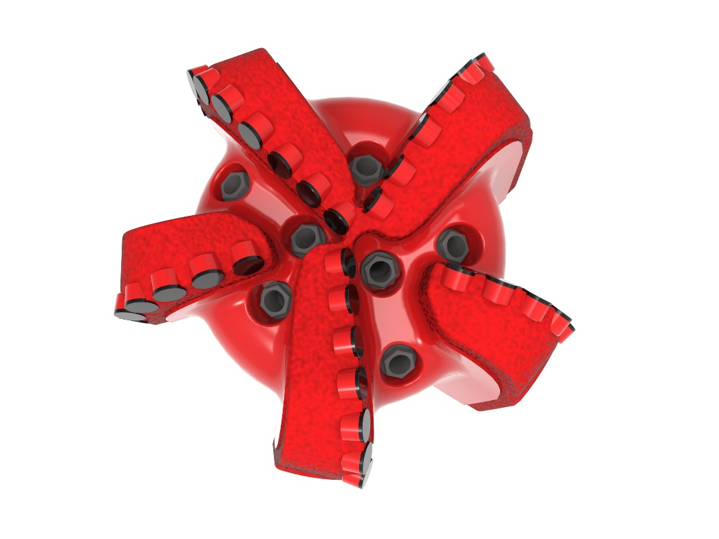
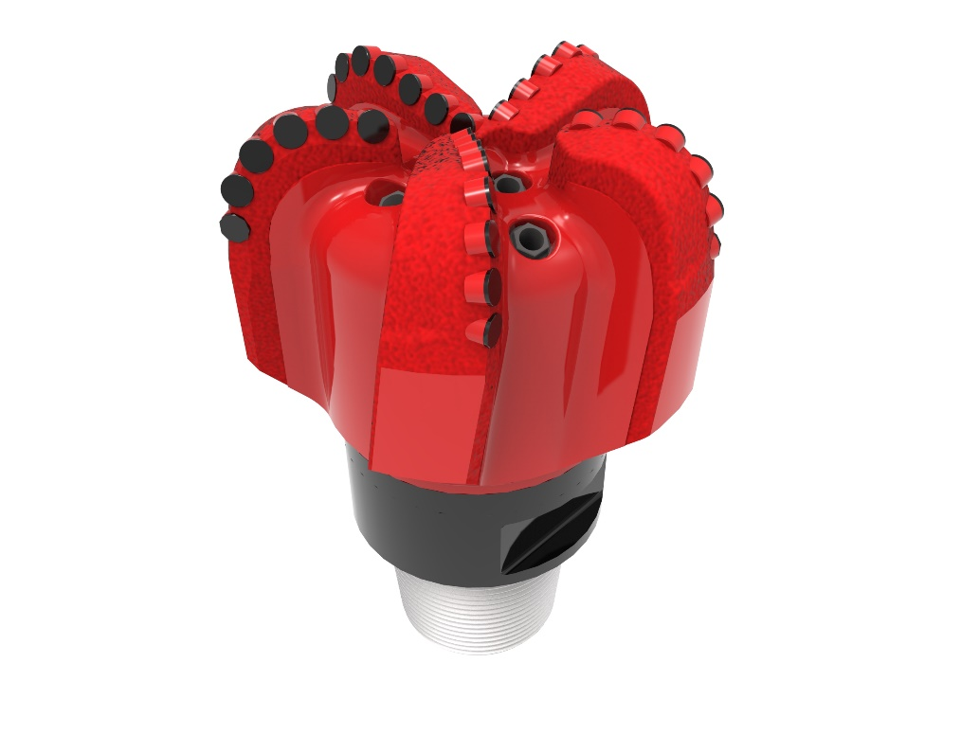

Drill Bit Specifications:
Cutter Size (Primary, Sec) | 3/4”
Cutter Count (Total, Gage, Back Ream) | 37, 6
Blade Count | 5
Gage Length (Inches) | 3.00
Nozzle Count (Primary, Sec.) | 7
Nozzle Series (Primary, Sec.) | 60
JSA (Sq. Inches) | 36.84
Max. TFA (Sq. Inches) | 2.60
Operating Parameters:
Max. Hydraulic Flow Rate (GPM) | 810
Make-up Torque (ft/lbs) | 40,563
Nominal Dimensions:
Overall Length (Inches) | *17.90
Make Up Length (Inches) | *13.03
Bit Breaker | SKB-21011
Connection | Ø6-5/8" API Reg.
Approx. Weight (Lbs.)  *Long tool joint available upon request (adds 6” to fishing neck, makeup and overall length, and 64 lbs. to approximate weight). | *215

Taylor-Made Features:

- Premium grade cutters maximize ROP and Life
- Nozzle configuration and large open face volume optimize blade cleaning and cuttings removal

519-SR7 Nomenclature Explained:

• | 5 | = | Number of Blades
• | 19 | = | Primary Cutter Size (19mm)
• | SR | = | Single Row Cutters
• | 7 | = | Number of Nozzles


